Name:

Date:

* Create tables according to ERD given.
* The Gender field only accepts these values (Male, Female and third gender)

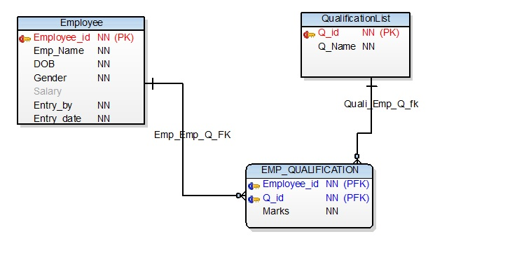

Insert these values to qualificationlist table.

|  |  |
| --- | --- |
| Q_id | Q_name |
| 1 | SLC |
| 2 | Intermediate |
| 3 | BE |
| 4 | ME |
| 5 | PHD |

Create an Entry form as given bellow.

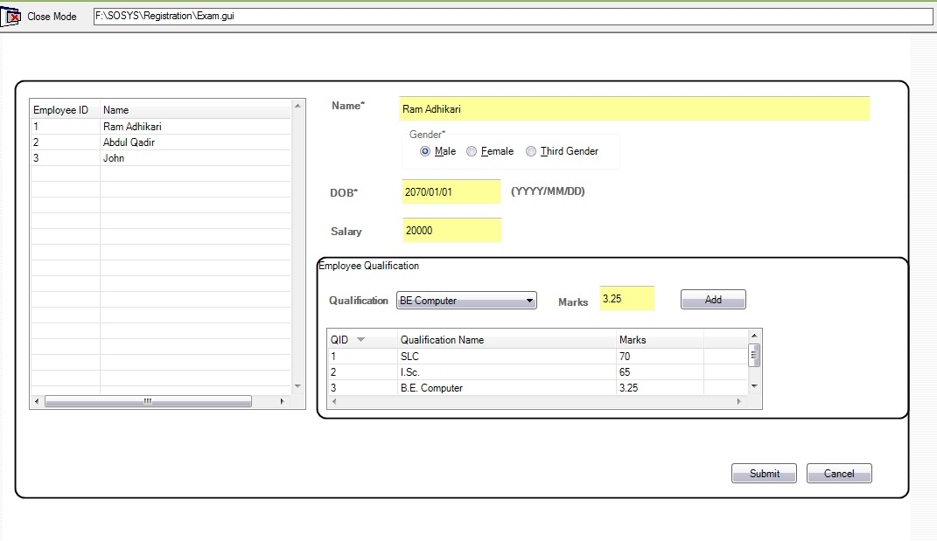

* Unique Employee_ID generate while saving Employee.
* Name Field only accepts character.
* DOB format (yyyy/mm/dd).
* DOB cannot be future date.
* Salary field only Accept number.
* There are multiple qualifications for an Employee.
* Marks field only accept number.